The Map Editor

Setting up
The map editor must have the “data” folder in the same location as it relies strongly on the folder hierarchy in “data”.

You may manually edit some settings by opening PPME.cfg (not many options available at this time).

The map editor also relies on PPMEDesktop.cfg, which specifies windows positions and size and various other attributes that may be edited through “Tools | Preferences”. By deleting this configuration file, you may reset the desktop of the map editor to a default state. This may be useful when you inherit a config file that used high screen resolutions and you’re now using for a, well, normal resolution.

The desktop configuration file is saved at map editor exit or by manually choosing “Tools | Preferences | Save”.

Creating a map
After starting MEditor, a popup window will appear. You must select the map size and the tileset/landscape to be used (in the release it’s only “Green”). You cannot skip this dialog.

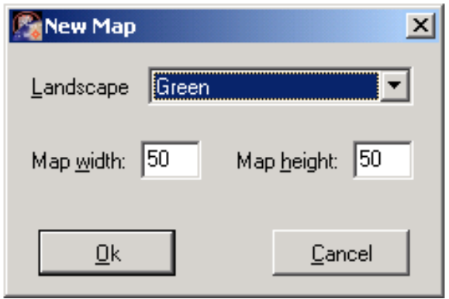

After pressing “OK”, a new map is created.

The map editor must have a map loaded at all time, so you cannot have an editor without a map to be edited. Also, only one map may be edited at a time (it’s a “single document” application ☺)

At any time, you may go to “File | New” to create a new map. You have to follow the same steps.

The map editor relies on data files in data/Gfx/Landscapes/<Chosen Landscape> to generate a new empty map. Actually, it looks for mapchunkNNN.dat files that are randomly used to generate the map floor.
At loading time, the map editor will recursively look for all *.dat files in the landscape chosen and it will list them in the “Object Manager Screen”, preserving the directory structure of the folder. It is advisable to keep your data files organized by types (walls, edges, trees and so on), to ease the map editing effort.

Also, at loading time it will parse the units data files located in data\dats, filling in the “Object Manager Screen” a tree structure for Infantry, Aircrafts and Vehicles. These units may be edited using the Units Editor (see below).

The editor has a set of floating windows that may be shown or hidden using the “Window” menu.

Editing a map
Take care that the map editor does not have an “undo” function.

In order to place a unit or a static (building) on the map, make sure the “Object Manager Screen” is shown. Make sure you select the battlegroup in the combobox. Then double click on a leaf in the object tree and click on the map. The unit should appear on the map. To delete one or more units placed on the map, select them, then right click and chose “Delete”. To cancel a selection, either select an empty space or right click and chose “Cancel”. Also, you may have selection filters based on the unit type (infantry, static, vehicle or aircrafts) or on the relation the player units have to the placed units (owned, enemy, neutral or friendly) by choosing the appropriate option in the “Edit” menu option.

Take care that placing on the map a building with the flag “Landscape” turned on (in Souless Editor, like edges) will make it not-selectable in the map editor and in the engine. Right now it’s one of the editor flaws. Make sure you place these objects before anything else if there’s a high probability of doing something wrong.

In order to modify some of the attributes of one or more map units, select them then press F8 or chose “Mission|Object Manager”. This screen should appear:
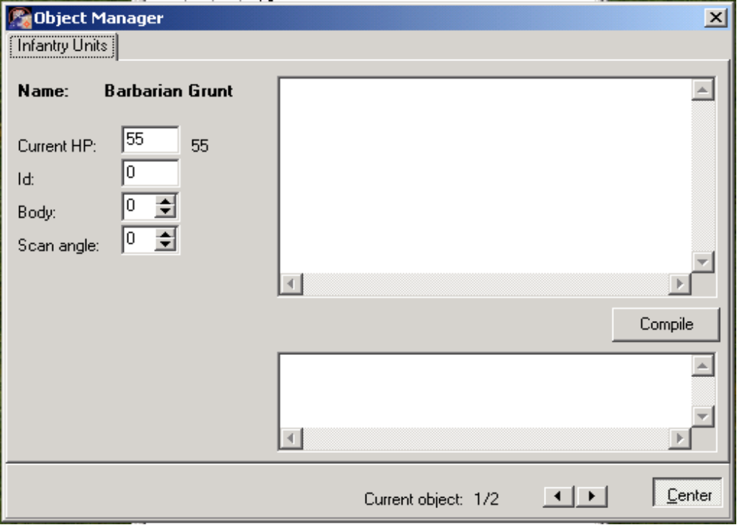
The modifications in this screen do not have direct result on the map.

The top memo box is used to place the unit script. Right click to get a popup menu, then choose “Load” to load a script or paste a script here or simply type the script. On disk, the scripts are placed in Data\Scripts and are organized on unit type. To compile the script, press “compile” and read the results on the bottom memo box. A successful compilation should read “Compile OK”.

Each unit placed on the map has an unique id. You may edit this id in the object manager screen, but if you set an id that conflict with an existing id, it will change to an unique value.

A unit placed on the map is a copy of the unit edited with the Units Editor, there is no relation between them whatsoever. Modifying a unit with Units Editor does not affect the map units. The statement is valid for buildings and for tiles.

Each unit belongs to a battlegroup. To create and edit battlegroups, select “Mission | Battlegroup Manager”. There are politic relations between the battlegroups (like enemy, friendly or neutral) that may be edited in the “Mission | Politics” screen. Creating battlegroups will make them appear in the combobox of “Object Manager Screen”. By default, two battlegroups exist, the player and the landscape, and they cannot be deleted.

Take care to select the battlegroup in the “Object Manager Screen” combobox before placing units on the map.

Each mission will require a script in order to have things happening there. Edit the script in “Mission | Mission Control Script”, either by using examples from data\scripts\mission or by consulting the scripting manual in “PPT Script Language Reference.doc”.

A map may need altitudes for each tile. In order to edit the heightmap, go to “Window | Altitude Screen”. Select the brush size, select the height to be added, activate the altitude editing by clicking the only button, then start clicking on the map. To deactivate the altitude editing, click again the button.

In order to edit the tiles on a map, do the same as placing a unit: from “Object Manager Screen” double click on the items that represent tiles (e.g. _north east short 3x3), then simply click on the map to place them.

You may want to randomly generate the tiles, the height map/edges or the ecosystem of a map. For this, click “Tools | Map Generator”.

For the tiles generation: each tile has a probability of appearing, that can be set from the combobox. The rate will then appear on the “appearance rate” list. The “tiles” list and the “appearance list” are on 1-on-1 relation. By clicking “OK”, the new tile map is generated. (please note that in 0.9.6 version there are still some bugs and the map is not correctly, if at all, generated).

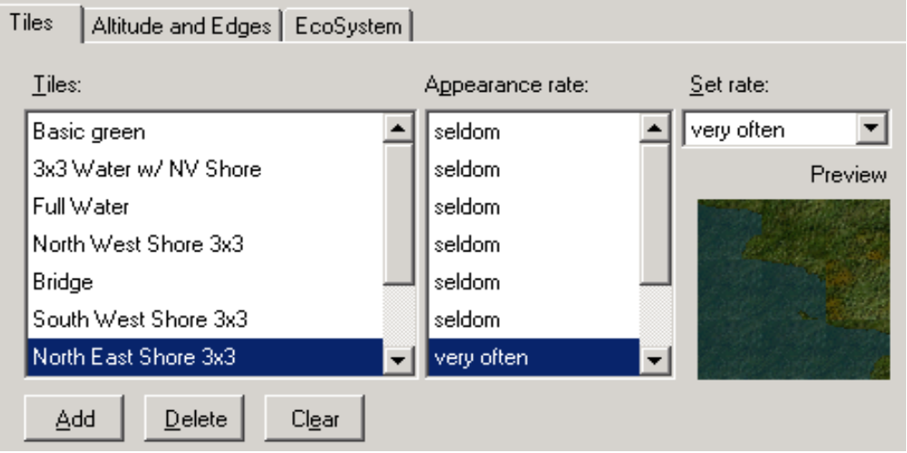
The heightmap generation does not work in version 0.9.6.

The ecosystem generator has two algorithms: random and probability field. The random algorithm has very few setups and the setup form should appear as:

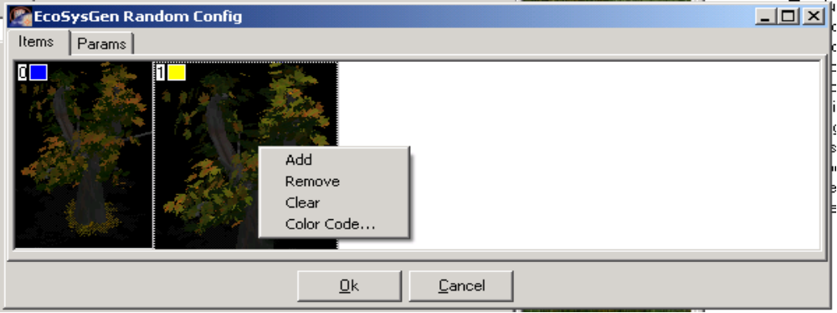
First, you have to add the items you want to generate, by using the popup menu. You may setup a color code to have a clear distinction in the preview area. Then, you must set the zone on the map to generate. Check the “Params” tab:

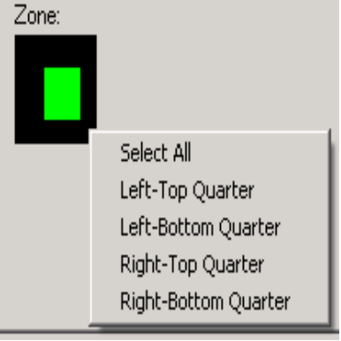

Select with the mouse a zone, or right click for default generation zones. Now click OK and either click “Preview” or “Generate”.
The “Probability field” method of generations is based on this idea: each ecosystem item (tree) has a probability function that influence (inhibit or support) the growing of other items in its vicinity. Thus, you have another option to edit, the deformation function:
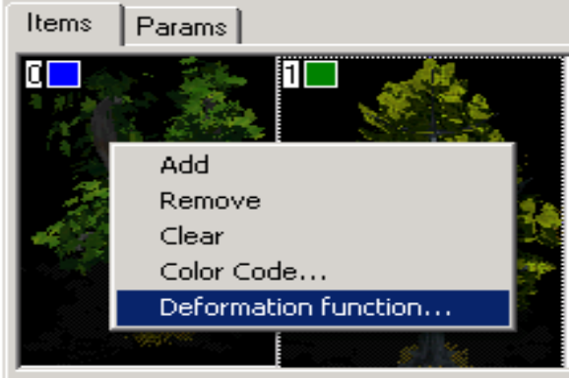
This will popup a curve editor dialog (see chapter 6) for a better explanation of how this screen works.

Souless Editor
This editor is used to edit the static (buildings) objects.

It is mandatory that the .dat file and the image file to be in the same directory. Thus, it is recommended that, after requesting a new object (“File | New” or at startup), to save it, otherwise the editor wont be able to find the sprite file. A “Cannot load image” error message box is the result of selecting the sprite before saving the dat file.

A static object may have layers, mask, height map and special points associated with it. To edit them, press the “Mask Editor” after you have specified the bitmap file.

The mask of a building is used to mark passable/not-passable tiles. The mask may only have two values (on/off).

The heightmap of a building may be edited and saved, but for the moment is not used by the engine. However, this may be easily hacked by modifying the heightmap in the map editor over the buildings.

A building may also have special points: the drop point (in case the building is a factory) is where the unit constructed will be placed on the map (of course, it is advisable to place this point outside the building mask). Also, there is the fire point, in case the building has firing points (like a pillbox) and there are the visual points. A building may have 0 or more visual points, in each of the point will be placed a visual subsystem, which may be controlled through the script (think like an observation tower). To edit any of these of the points, click the “Points” tab, click the desired radiobox then click the picture.

Also, a building may have multiple layers, in order to have animated buildings. Each layer may be assigned an animation. Check “Data\Gfx\Landscape\Green\Buildings” for r_headquarters.bmp, hq_fan_up.bmp and hq_fan_down.bmp to see how it’s done.

Units Editor
Units Editor is used to edit data files for infantry (data/dats/aiinfantry.dat) and vehicles (data/dats/aivehicles.dat).

Take care that modifying info for one unit does not automatically save the changes. You have to manually press the “Save” button.

Units have a so called “skeleton”. For the infantry, it consists of the fire holes and visual points (one point for each sprite orientation). For the vehicles (ground – like tanks), the skeleton consists of the fire points, observation points and fitting the turret to the body.

It is important to setup the points. For the infantry, the fire holes are essential, otherwise when the unit fires, the projectile will be misplaced. For the vehicles, it is important to correctly fit the turret and body, the fire hole and the observation points (because these units sprites usually span for more than one cell like infantry, it is important that the visual subsystem match to the sprite).

The vehicles feature a tab called “Visual” along with “Audio”, “Armor”, “Crew” and so on. This is used right now to setup the dying behavior, it is very useful for the aircrafts so they wont suddenly disappear.

Map Chunk Editor
Map Chunk Editor is used to design tiles. These tiles will be read by the map editor and listed in the “Object Manager Screen” tree.

A tile may have size from 1 to 5, meaning 1x1 to 5x5 tiles. Each subtile (cell) may have 3 types: water, shore and ground. Click an cell in the image to get a popup menu:

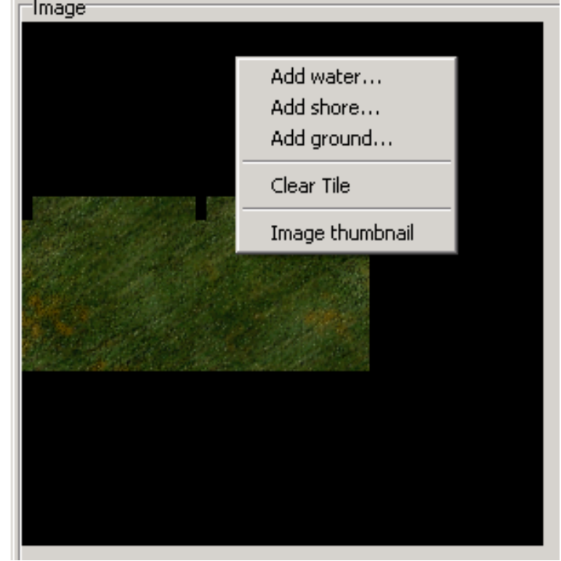

Click “Add water/shore/ground” and select the desired bitmap.

The .dat file resulting from saving must be saved in the root of the landscape (e.g. data/gfs/landscape/green).

Sprite Editor
It’s used to assemble bitmaps into sprite sheets. It’s fairly easy to used and if you do not like it, you may always use Adobe Photoshop to assemble the sprite sheet ☺

Curve Editor
This editor is meant to be used to edit various elements for the upcoming particle system. The curve editing screen, however, is also present in the map editor, in the probability field ecosystem generator.

First, create a new item database (“object stream”) by using “File | New” or load one using “File | Open”.

Right click an empty line or an entry to get a popup:

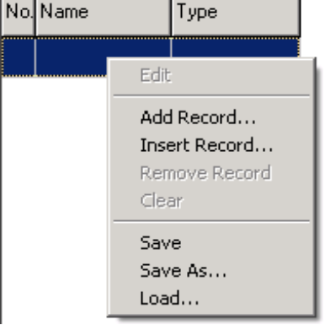

Use “Add Record” or “Insert Record”. Then use edit on an item.

In the curve editing parameters, you may chose the type of curve (linear, ellipsoid, polynomial, scripted or composite) and the type of the equation (parametric, implicit or explicit). Set the appropriate parameters (see below) and use the button labeled “G” to get a preview.

For the linear curve, the curve type is “explicit” and the parameters required are “A”, “B” and “C” (A*x + B*y + C = 0).

For the ellipsoid, the curve type is “parametric” and the parameters required are “A” and “B” (x = A * cos(u), y = B * sin(u)).

For the polynomial curve, the type is “explicit” and the parameters required are “N” and “A0” to “An-1” (y = An-1*x^n + …. + A0).

For the scripted curve, the type may be “parametric” or “explicit”. For parametric, you must implement two functions: XParam and YParam. For explicit, you must have a function called “YFromX”. Example for an astroid curve script:

var XParam(const u)
{
var sinu = sin(u);

return GetParam("A") * sinu * sinu * sinu;
}

var YParam(const u)
{
var cosu = cos(u);

return GetParam("B") * cosu * cosu * cosu;
}
The parameters obtained by GetParam function must be edited in the parameters box.

The composite curve is not yet implemented.

